What is too much screen time during a pandemic?

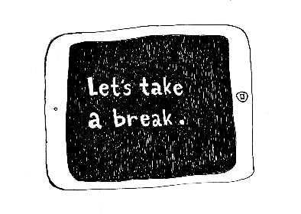
Many parents and carers are probably worried about the amount of screen time that children are engaging in at the minute. However, research shows that screen time is not dangerous, it is up to you as a parent to decide how much is good for your child.

- Parents should monitor what their children are watching and engaging in online
- Parental controls should be on all devices
- Keeping tour child safe online is most important
- Facetime and online gaming can keep children and children connected with their peers during lockdown

- Allowing screen time does not mean other routines go out the window.

- Readjusting family rules for screen time should be considered, such as after schoolwork or daily exercise.

- Keep rules like no screens after a certain time to ensure they are getting a good night’s sleep, which is crucial currently.

- Make children aware that when normal life resumes the rules will change back to what suits family life best.

There are going to be days when parents feel exhausted, drained and overwhelmed. Letting children have some extra screen time so you can have some important ‘me time’ is ok. Listen to yourself and do what is right for you and your family.

