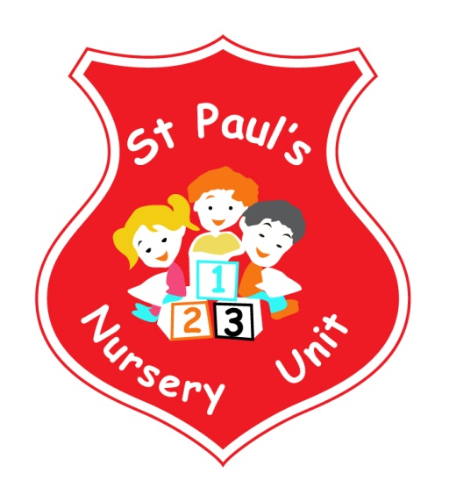

**MARCH NEWSLETTER**

**Themes of the Month:** Healthy Eating

**Colours of the Month:** **Green**



**Shape of the Month:** Oval

**Numbers of the Month:** Revise 1-5 and number 6

**Happy Healthy Kids**

We are launching our Happy Healthy Kids programme on Wednesday 28th of March at 12.45. Our focus is on raising parent awareness of the importance of increasing physical activity and reducing screen time. Parents are invited to to the nursery to join their child for some outdoor play. Interacting and enjoying some 1-1 physical play with your child.

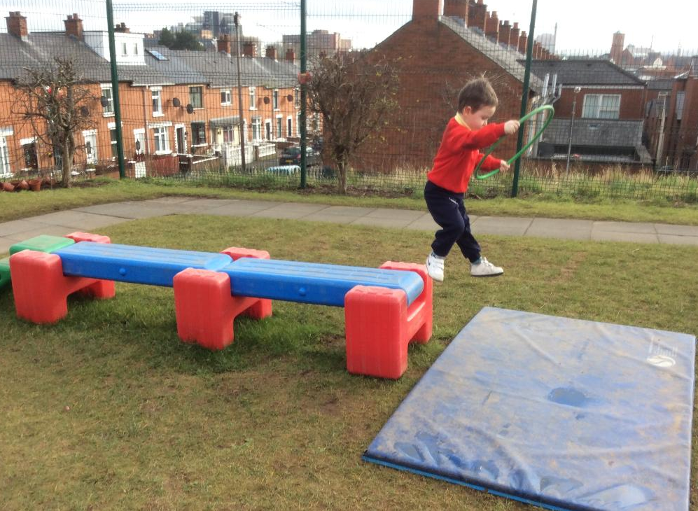

**Parent & Children Workshops**

Miss McGarry will be running an After-School workshop for our parents and children. The workshop’s will begin on Thursday the 15th of March from 1.30 to 2.15pm. Notes will follow with further details





**Coffee Morning**

Thank you to all the parents who came to our coffee morning on the 28th of February! We will be having another coffee morning on Wednesday the 14th March. All are welcome to come along and have a cuppa and a chat!





**Green Day**

We are having our annual Green Day on Friday the 16th of March. Children can wear something green to celebrate St. Patrick’s Day. The school will be closed on Monday the 19th

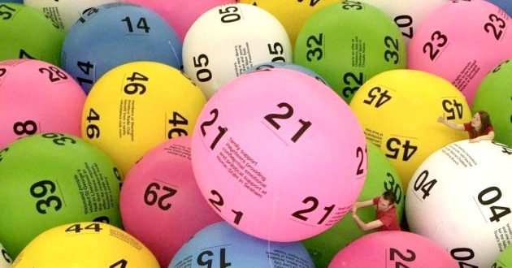

**Bonus Ball**

At the coffee morning last week it was decided that a good way to raise school funds was by using the Bonus Ball! Parents can buy a Bonus Ball number (£1.00 each) from their child’s teacher and then put their name on the sheet which is up on the office door.



Happy Mother’s Day to all our Mummy’s, Grannies and Aunties!

**School Weather Closures**

We would like to thank you all for your cooperation and understanding following the recent weather closures.

**Songs this Month:**

* I’m a Little Leprechaun
* Hey Diddle, diddle
* Growing Seeds
* Higgledy, Piggledy

**Dates For Your Diary**

**Wednesday 14th March:** Coffee Morning

**Friday 16th March:** Green Day

**Monday 19th March:** School Closed

**Thursday 29th March:** Holy Thursday School closes at 11 am

**Monday 2nd April to Friday 6th April School closed for Easter Break**



Happy Birthday to Charlie, Brian and Reilly who all have

Birthdays this month!

**Reminder:**

* Take home all of your child’s art from their pigeon hole in

the hall.

* Leave a change of clothes on your child’s peg in case of an

accident.

* Please send all snack/dinner money on a Monday morning

to facilitate banking.

* For Child Protection purposes - mobile phones should not be

used on Nursery premises.

* Mrs McLogan is the Designated Teacher for Child Protection

in the Nursery. If you have a worry or concern regarding

your child please bring any concerns to her. In her absence please see Mrs G. McCotter Vice Principal (based in St Paul’s Primary school) contact her on 90328968

