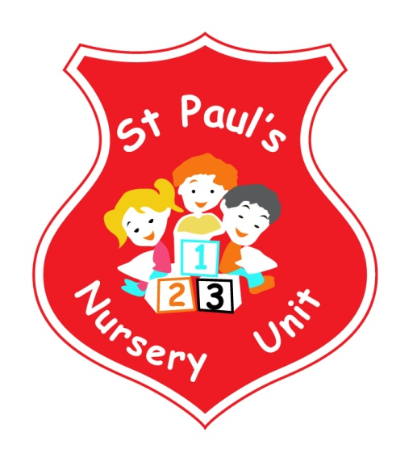

**MAY NEWSLETTER**

**Themes of the Month:** Wild Animals & Mini Beasts

**Colours of the Month:** **Pink**

**Shape of the Month:** Triangle

**Number of the Month:** 8

**Theme Of The Month**

This month’s theme is wild animals and mini beasts. Talk to your child about the types of animals we see at the Zoo and in the forest. Our lending library has some books that you can use to chat about this topic. As part of our theme Party Animals will be visiting our Nursery on Friday 25th May with their reptiles!!

**Homewor**k

Over the month of May the children will be engaging in a range of activities which will promote their learning and development. The colour we will focusing on this month is **Pink**, if you have any objects you would like to share that are unusual please feel free to bring them in to share with the class.

Mathematics – if your child spots the Number **8** or a triangle, take a photo and email it into school where it will be displayed and talked about. Email your pictures to: [stpaulsnurseryunit@yahoo.co.uk](mailto:stpaulsnurseryunit@yahoo.co.uk)

**Induction Day**

On Wednesday 6th of June we will be having an Induction Day for new parents joining our nursery. School will finish at 12.40 on this day to allow us to prepare for the Induction. Please ensure all children are collected early.

**Parents Relaxation**

Following our last Parent Coffee morning it was decided that we would organise a Parents Relaxation Course.

The course will take place on Wednesday’s at 9.30 on the following dates:

**2nd May 6th June**

**23rd May 13th June**

**30th May 20th June**

We only have **3 spaces** left for these courses! Please see Mrs McLogan if you would like to attend.

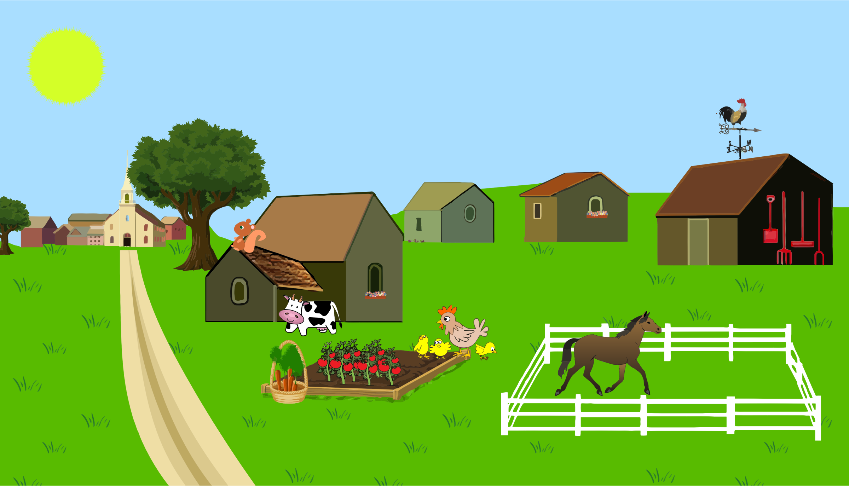



**The Farm Trip**

Well done to all our children for your excellent behaviour on our trip to the Farm. You are a credit to your parents and our school!

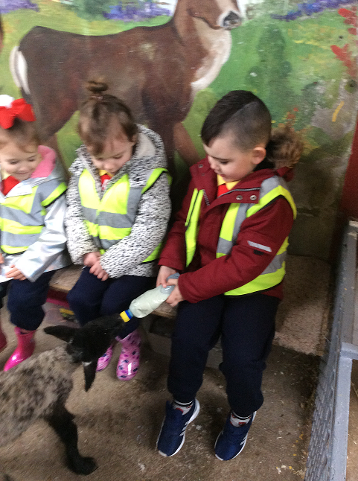

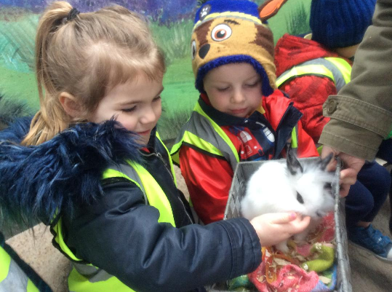

**School Uniform**

Summer dresses are **NOT** practical for the nursery curriculum. As you know we have a lot of outside play and they can cause children to injure themselves with friction burns from the slides, being caught on bicycles and other accidents. The children should continue to wear their full uniform and on extremely hot days they may wear navy knee length shorts. School shorts are available from Truly Fare and cost £6.99. All children should wear Velcro fastening trainers, **no laces**, and no sandals please!

**Sun Cream**

As the weather improves, please remember to pack some sunscreen and a hat in your child’s bag, so they can be protected when they play outside.

[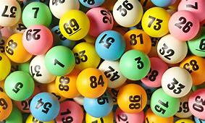](https://www.bing.com/images/search?view=detailV2&ccid=CHEbvL0+&id=2199B86014B4BC78EF0EEEE4E98E2003182117A5&thid=OIP.CHEbvL0-PufSFq--f6EZKgHaEc&mediaurl=http://taxfoundation.org/sites/taxfoundation.org/files/docs/Lottery-Balls-014_0.jpg&exph=1536&expw=2560&q=lottery+ball&simid=608046051398324010&selectedIndex=0&adlt=strict)

[](https://www.bing.com/images/search?view=detailV2&ccid=CHEbvL0+&id=2199B86014B4BC78EF0EEEE4E98E2003182117A5&thid=OIP.CHEbvL0-PufSFq--f6EZKgHaEc&mediaurl=http://taxfoundation.org/sites/taxfoundation.org/files/docs/Lottery-Balls-014_0.jpg&exph=1536&expw=2560&q=lottery+ball&simid=608046051398324010&selectedIndex=0&adlt=strict)

**Bonus Ball**

The bonus ball rolls over again! Please continue to support our fundraising we use this for all the fun activities we have for the children!

**Dates for Your Diary**

|  |  |
| --- | --- |
| Wednesday 9th May 2018 | Closing date for Acceptance Forms for Nursery places |
| Friday 25th May 2018 | Party Animals visit to Nursery |
| Wednesday 30th May 2018 | Primary School Induction at 1.30pm |
| Wednesday 6th June 2018 | Nursery Induction Day at 1.30pm  (**Nursery closes at 12.40pm**) |
| Wednesday 13th June 2018 | One World Day at the Primary School  (See Mrs McLogan for tickets) |
| Friday 15th June 2018 | Graduation Ceremony at the Primary School  () |
| Friday 22nd June 2018 | School trip to Funky Monkeys, Newtownabbey |
| Thursday 28th June 2018 | Fitness Freddy End of Year Finale at 12.30pm  Parent and Child Dance Session |

**Reminder:**

* Please pass your email address to Ms McLogan or Miss McGarry **ASAP** so that we may forward you your

child’s class observations.

* Your child works very hard to produce beautiful art, please remember to take all finished pieces home.

Each child has their own pigeon hole; any completed work will be placed there.

* **Leave a change of clothes on your child’s peg in case of an accident.**
* Please send **all** snack/dinner money on a **Monday morning** to facilitate banking.
* For Child Protection purposes - mobile phones should not be used on Nursery premises.
* Mrs McLogan is the Designated Teacher for Child Protection in the Nursery. If you have a worry or concern regarding your child, please bring any concerns to her. In her absence please see Mrs G. McCotter, Vice Principal (based in St Paul’s Primary school) contact her on 90328968.



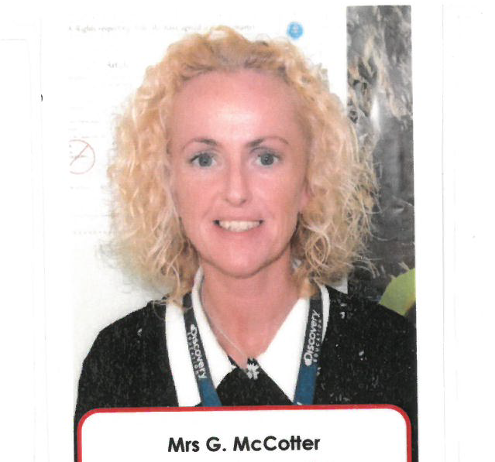



Happy Birthday to Alice, Carter, Lily, Maria and Oisin who all have birthday’s this month!

**Songs This Month**

**Ladybird, Ladybird**

Ladybird, Ladybird fly away home;

C:\Users\St Pauls\AppData\Local\Microsoft\Windows\Temporary Internet Files\Content.IE5\2OZ1O4C5\MC900034141[1].wmf

Your house is on fire, and your children all gone;

All but the youngest, whose name is Anne,

And she hid under the frying pan.

(This can be sung to the tune of Pussycat, Pussycat, Where have you been?)

**There’s A Tiny Caterpillar**

There’s a tiny caterpillar on a leaf – wiggle, wiggle

C:\Users\St Pauls\AppData\Local\Microsoft\Windows\Temporary Internet Files\Content.IE5\2OZ1O4C5\MC900339866[1].wmf

There’s a tiny caterpillar on a leaf – wiggle, wiggle

There’s a tiny caterpillar, tiny caterpillar,

There’s a tiny caterpillar on a leaf – wiggle, wiggle.

* He will eat the leaves around him ‘til he’s full – munch, munch
* A cocoon is what he’s spinning for his home – spin, spin
* Then he’ll be a butterfly and fly away – flap, flap.

**Busy Bee Hand Game**

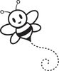

Here is the beehive, where are the bees?

Hiding inside where nobody sees.

Here they come now out of the hive

One, two, three, four, five.

**Down In the Jungle**

Down in the jungle where nobody goes,

There’s a great big Gorilla washing his clothes;



With a rub-a-dub here,And a rub-a-dub there;

That’s the way he washes his clothes.

A boogie, a woogie, a boogie – yeh!

A boogie, a woogie, a boogie – yeh!

A boogie, a woogie, a boogie – yeh!

And that’s the way he washes his clothes.

Repeat for different animals e.g. mouse (tiny voice) Snake (hissy voice)