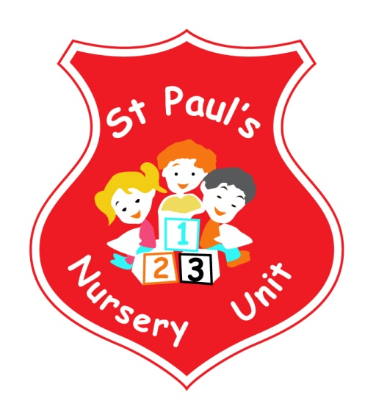
JUNE NEWSLETTER
Themes of the Month: Summer & Sea World
Colours of the Month: Gold

Shape of the Month: Revision
Number of the Month: 1 2 3 4 5 6 7 8

Theme Of The Month
Over the next few weeks we will be investigating the Sea World and Summer. We will be discussing favourite holiday destinations such as the caravan, Newcastle, Bundoran, Ballycastle as well as Portugal, Spain and the rest of the world. We will encourage children to recall their own experiences, whether it be home or abroad. Children will have the opportunity to role play as we will change the home area into a garden area with a barbeque! There will also be summer clothes including sunglasses, flip flops and scuba gear to try out sea diving! The children will also be exploring sea animals in the sand and water areas and will get a chance to look at stones and shells using the weighing scales and different spoon sizes. Weather permitting we will be outside for longer periods, please remember to put sun cream on your child before they come to school. And also to pack hats / caps in their bags.
St Paul’s Primary Open Day
The Primary School Induction Day for children going to St. Paul’s Primary School is on Wednesday the 30th of May at 1.30pm. Here you will get to meet your child’s Teacher, have a look at our classrooms and receive information for your child starting in September. Please ensure your child is collected from Nursery at 1.15pm promptly.

Nursery Open Day
On Wednesday 6th of June we will be our Induction Day for new parents joining our nursery. School will finish at 12.30 on this day to allow us to prepare for the Induction. Please ensure all children are collected early.

Sports Day
The Nursery Sports Day is on Friday 8th June. Children should be brought to Nursery at 9.30am and will be able to go home afterwards at 11.30. A parent or guardian must attend this Sports Day.

Sure Start Visit
Children from the Beechmount Sure Start at Blackie River will be visiting our Nursery on Monday 11th June to get a taste of day in Nursery School! We can’t wait for all our big boys and girls to show them how much fun we have!

One World Day
On Wednesday 13th June our Primary School will be hosting its annual One World Day celebration. Our school is incredibly diverse and One World Day celebrates this with singing, dancing, music and food from across the globe. The nursery children will open the show with a group song! All children should come to nursery as normal on the morning of One World Day. Tickets cost £5.00 per person and are available from Mrs McLogan.
Graduation Day

You are cordially invited to your child’s Nursery Graduation Day! We will be having our Graduation Ceremony and Breakfast Buffet in the Primary School Hall on Friday 15th June. All children should be present in the hall at 9.30 sharp. Tickets cost £2.00 per person and are available from your child’s teacher. A note regarding details will follow in the coming weeks.

Funky Monkey’s School Trip

Our end of year trip to Funky Monkey’s will be on Friday 22nd of June. The cost of this trip is £5.00 per child. Please ensure all monies are passed to teachers by Monday 18th June.

Sun Cream

As the weather improves, please remember to put some sunscreen on your child before you come to school and a pack a hat in your child’s bag, so they can be protected when they play outside.
Fitness Freddy’s Final Dance Off
Parents and Guardian’s are invited to attend our final session with Fitness Freddy on Thursday 28th June at 12.30 ! Come along and join in with our groovy moves for the last time!

Thank You!

Well here we are at the end of our Nursery year. We hope you and your child have enjoyed your time with us as much as we have enjoyed it with you and that this has been a positive experience for everyone.

We are particularly sad that for some, this year will be your final year with us as all of your children have moved on to “big school”. It has been our pleasure to get to know all our parents and families over this year and we would like to wish you all well for the future and thank you for all the support you have given St. Paul’s Nursery and our Staff. The Staff would like to say a special thank you to all of you and wish every child lots of luck as they transition into BIG SCHOOL and we look forward to seeing some of our little ones return again in September. Best wishes from Mrs McLogan and all the staff.

Reminder:
- Your child works very hard to produce beautiful art, please remember to take all finished pieces home.
Each child has their own pigeon hole; any completed work will be placed there.
- Leave a change of clothes on your child’s peg in case of an accident.
- Please send all snack/dinner money on a Monday morning to facilitate banking.
- For Child Protection purposes - mobile phones should not be used on Nursery premises.
- Mrs McLogan is the Designated Teacher for Child Protection in the Nursery. If you have a worry or concern regarding your child, please bring any concerns to her. In her absence please see Mrs G. McCotter, Vice Principal (based in St Paul’s Primary school) contact her on 90328968.
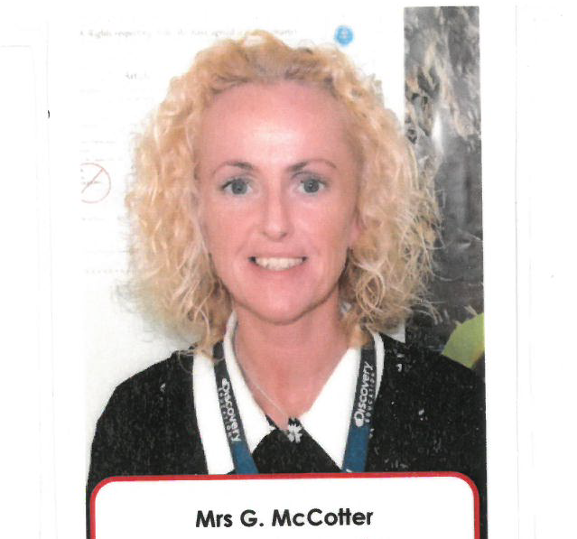

Happy Birthday to Cory, Sophia, Sean, Winnie and Conor Og who all have birthday’s this month!

