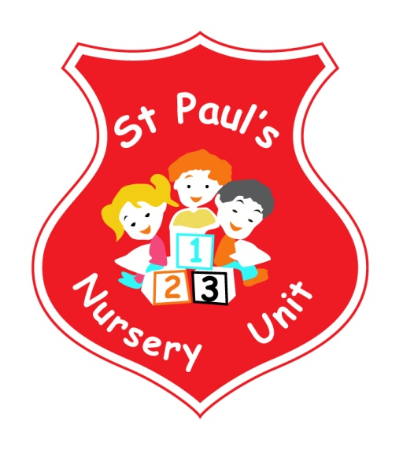
Welcome to our First St Paul’s Newsletter 2018
Themes of the Month: Autumn & Halloween
Colours of the Month: Blue & Black
Shape of the Month: Circle O
Number of the Month: 1
Settling In
We wish to thank you for your co-operation during the settling in time.
We appreciate that it can be inconvenient for some parents. However, we are sure you will agree that it is very important that the children are happily settled in school and routines established.
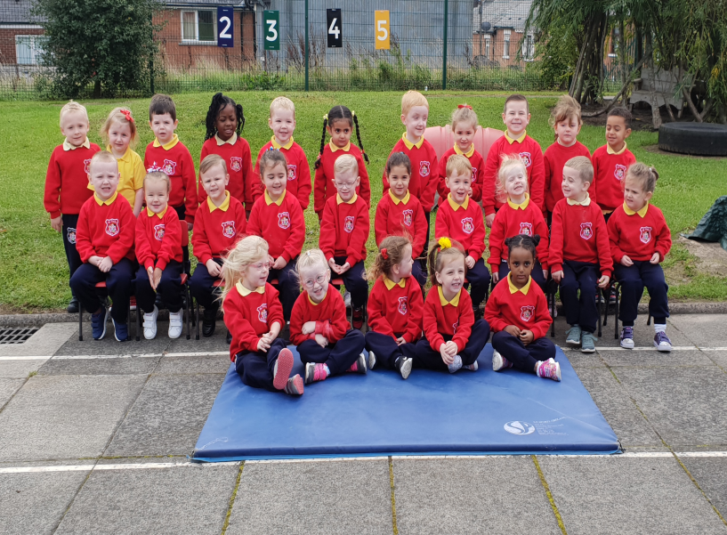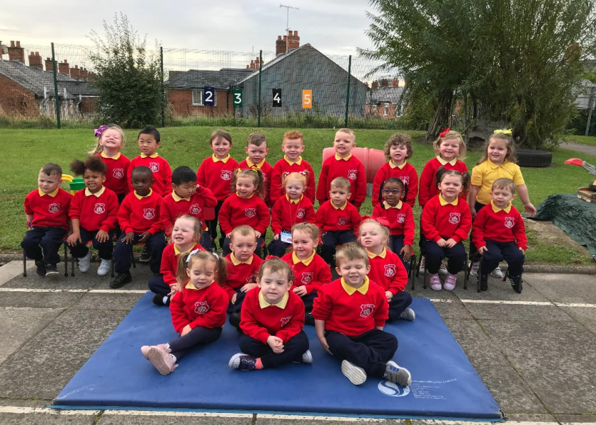

Talk to your child about their school day. Encourage them to tell you what they played with, who they played with and what they had for snack. This will help them to establish routine and recall information. They may be small but don’t underestimate their talents!
School Meals
If your child is entitled to free meals, please make sure you have applied for these ASAP, if you have not already done so. Dinners cost £2.50 per day, plus weekly break costs £5.00. Weekly payment for dinners and break will be £17.50 and should always be paid on a Monday morning.
Rhymes and Songs
Every month we will send home four rhymes/songs which we would ask you to say/sing with your child. Research shows that children who are exposed to rhymes/songs/stories by age 4 find it easier to learn to read.

Fitness Freddy!
Fitness Freddie has returned!! The children love his weekly visits, keeping us fit and strong!

Music Therapy
We will be enjoying a session of music therapy every Friday for the next 4 weeks. The children will get to learn new songs and experience musical instruments.

Wellie Boots
As the weather moves into autumn we would be grateful if you could send in a pair of wellie boots for your child to keep in school (ensure their name is written on the inside). This will ensure the children can still have some outside time on wet days.

Parent’s Meeting
These meetings will be held on Friday 26th October 2018 and a sheet will be displayed on each classroom door. Please select a 10 minute slot that suits you to meet with your child’s class teacher. The meetings will be held from 11.00am.

Book Fair
We are holding a Book Fair, week beginning Monday 8th October. The school receives books from a percentage of the profits. The more books sold the more books the Nursery will receive!

Fancy Dress
Friday 26th October will be a fancy dress party for the children; school will start at 9.00am and finish at 11.00am on this day. We would ask for a small contribution of £1.00 towards Nursery funds.

Halloween Break
School will finish at 11.00am for all children in the Nursery on Friday 26th October 2018 and will reopen on Monday 5th November 2018.

Macmillan Coffee Morning
Thank you to all our families for the support of our Coffee Morning. We raised £150.00 for Macmillan Cancer Research. Many Thanks!!

Homework
This month please encourage your child to identify blue and black in the community and bring it in for our Blue table. This will provide opportunities to talk about different shades of blue. Mathematics – if your child spots Number 1 or a Circle take a photo and email it into school where it will be displayed and talked about.
Email to: stpaulsnurseryunit@yahoo.co.uk

Reminder:
- Take home all of your child’s art from their pigeon hole in the hall.
- Leave a change of clothes on your child’s peg in case of an accident.
- Please send all snack/dinner money on a Monday morning to facilitate banking.
- For Child Protection mobile phones should not be used on Nursery premises.
- ‘Like’ our Facebook page for pictures and updates!

Happy Birthday to Dania, Justin, Alexis,
Jessica and Fionn who all have birthdays this month!

