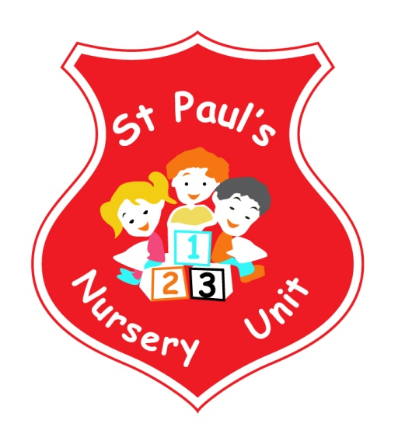
NOVEMBER NEWSLETTER
Themes of the Month: Autumn & Myself and My Family
Colours of the Month: Brown & Orange
Shape of the Month: Square
Number of the Month: 2
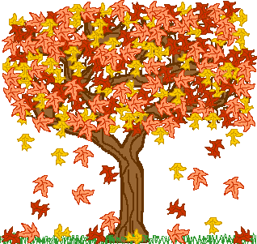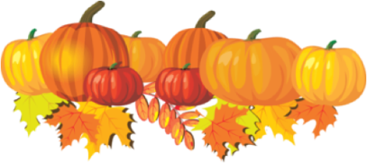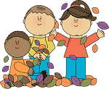
Hello Everyone!
We hope you are well! It’s great to see the children settled in so quickly and having spoken with them, they are all enjoying the play activities and making new friends!
Book Fair
Thank you to everyone for your support during the book fair, it was a great success and our school raised £314.00 and we received £79 to spend on books! We got lots of lovely new books for our lending library.
Theme Of The Month
This month’s theme will continue to be autumn. We will develop autumn with the children through colour and leaves. Children will have the opportunity to use leaves in their art and working with play dough, where we will be encouraging them to make leaf prints and discuss the colours of autumn. The children will also begin simple paint mixing to create new colours. We will also add leave to the interest table, jigsaw and number areas for counting. If you are out and about, ask your child to look for the signs of autumn and bring in some colourful leaves, conkers and pinecones for our Theme Table. We will be developing this theme throughout the month to include animals in autumn.
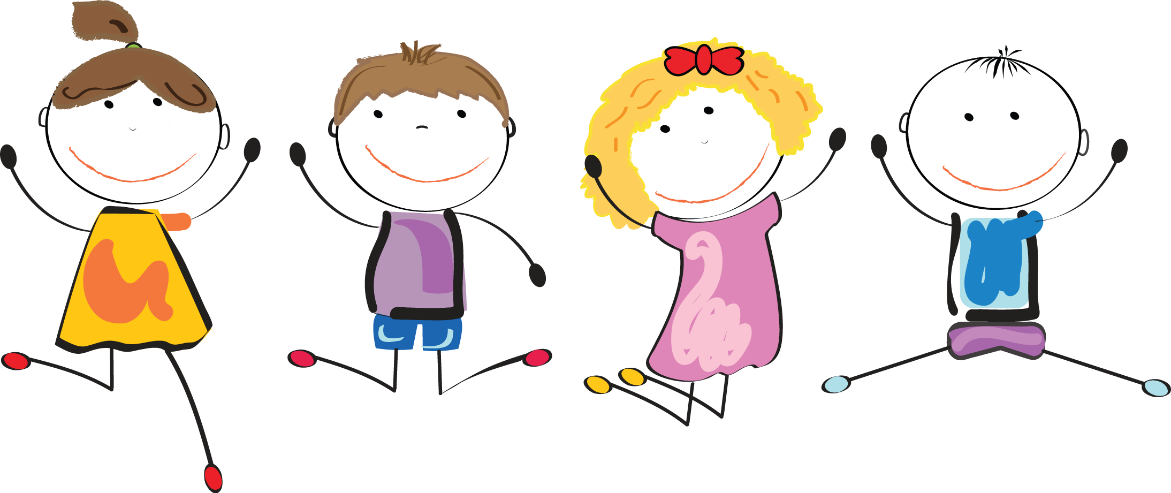
Fitness Freddy!
Fitness Freddie will be here throughout November to teach the children all about exer cise and keeping fit and healthy!

Dental Health Visit
The Dental Health Team will be visiting our Nursery on Wednesday 14th November to chat with the children about the importance of oral hygiene and how to brush properly and keep their teeth beautiful and strong.
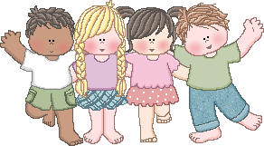
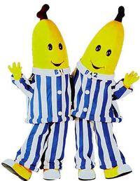

Children In Need – Pyjama Day

On Friday 16th November the children will come to school in their pyjamas and bring in their favourite bedtime book for the Pyjama Day. We would ask for a donation of £1.00 in aid of Children In Need.

Homework
This month please encourage your child to identify Orange and Brown in the community and bring it in for our table. Mathematics – if your child spots the Number 2 or a Square take a photo and email it into school where it will be displayed and talked about. Email your number pictures to: stpaulsnurseryunit@yahoo.co.uk

Songs this Month:
- Baa Baa Black Sheep
- Twinkle Twinkle Little Star
- Incy Wincy Spider
- Humpty Dumpty

Encouraging Independence
Throughout the months of November and December we will be working with your child to encourage their independence, social and emotional well being. We do this in a variety of ways including:
- Encouraging your child to take off their own coats/jumpers – you can help with this at home
- Encouraging your child to follow the snack time routine (choosing own snack, buttering bread, pouring drink and clearing up)
- Independently selecting materials to use at activities.
- Encouraging independent thinking
- Problem solving when sharing or taking turns
- Showing respect for others including equipment and staff
- Following nursery rules e.g. appropriate sitting and listening at story time, tidy up routines and joining in at group activities
We hope that you will see the progression in your child as we promote these activities.

Reminder:
- Please pass your email address to Ms McLogan or Miss McGarry ASAP so that we may forward you your
child’s class observations.
- Take home all of your child’s art from their pigeon hole in the hall.
- Leave a change of clothes on your child’s peg in case of an accident.
- Please send all snack/dinner money on a Monday morning to facilitate banking.
- For Child Protection purposes - mobile phones should not be used on Nursery premises.
- Mrs McLogan is the Designated Teacher for Child Protection in the Nursery. If you have a worry or concern regarding your child please bring any concerns to her. In her absence please see Mrs G. McCotter Vice Principal (based in St Paul’s Primary school) contact her on 90328968.

Please take a moment to like and share our Nursery Facebook Page! We hope to have lots of information on upcoming events and lots of pictures of the activities Our Nursery School gets up to! Search for St. Paul’s Nursery Unit and look for our school crest!

Junk Material
We would greatly appreciate any junk materials you can source for us, for example:
- Magazines i.e. tractor, cooking, kids magazines etc
- Buttons, lids, boxes and caps
- Natural materials such as pine cones, acorns, leaves and pebbles

Happy Birthday to Hala and Sean who both have birthdays this month!

