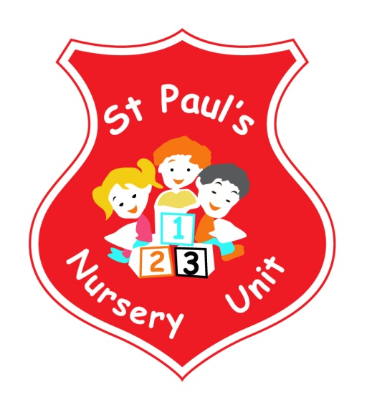
DECEMBER NEWSLETTER
Themes of the Month: Christmas & Celebrations
Colours of the Month: Red & Sliver

Shape of the Month: Star
Number of the Month: 3

Theme Of The Month
Christmas will be incorporated into the majority of our nursery activities throughout the month of December. The children will have the opportunity to wrap presents, write letters to Santa, create pictures and models of toys they want or that they think Santa’s elves might be making in his workshop. There will be lots of activities to keep the children in the spirit of Christmas as well as helping them develop an understanding of the meaning of Christmas.

Fitness Freddy!
Fitness Freddie will be here on 3rd, 10th and 17th December for special Christmas Workouts.
Homework
This month please encourage your child to identify Red and Silver in the community and bring it in for our table.
Mathematics: if your child spots the Number 3 or a Star take a photo and email it into school where it will be displayed and talked about. Email your number pictures to: stpaulsnurseryunit@yahoo.co.uk

Songs this Month:
- When Santa got stuck up the chimney
- Twinkle Twinkle Little Star
- Away in a Manger
- Snowflake, Snowflake

Dates For Your Diary

Tuesday 4th: Cinema Trip! We will provide party bags, cinema tickets and a Burger King lunch! If parents could pay £3.00 per child to cover the cost of the bus.
Wednesday 5th: Christmas Dinner
Thursday 6th: ‘The Litter Elf’ will visit the nursery for a Christmas Visit and to talk about re-cycling.
Friday 14th: Our Christmas Nativity Show at 9.30 am in the Primary School. Children should be brought to the Primary school for 9.15am. It would be lovely to have a great turnout for your child’s first ever school performance. Children will be able to go home after the performance. Tickets are available from class teacher and cost £2 per person.

Thursday 20th: To finish the year we will have our Christmas Party! Santa will be visiting us to give a little present as the children go home. Come along from 1pm and get your child’s photo taken with Santa.

Ballots
We are holding a raffle this Christmas to raise Money for new bicycles. Tickets are £1:00 per strip and available from the Nursery.
Prizes are Fantastic and include vouchers, tan sets, flowers, biscuits, processco, wine and much much more.

Reminder:
- Take home all of your child’s art from their pigeon hole in
the hall.
- Leave a change of clothes on your child’s peg in case of an
accident.
- Please send all snack/dinner money on a Monday morning
to facilitate banking.
- For Child Protection purposes - mobile phones should not be
used on Nursery premises.
- Mrs McLogan is the Designated Teacher for Child Protection
in the Nursery. If you have a worry or concern regarding
your child please bring any concerns to her. In her absence please see Mrs G. McCotter Vice Principal (based in St Paul’s Primary school) contact her on 90328968

Happy Birthday to Emma, Jamie and Emmanuella
who all have birthdays this month!

We would like to take this opportunity to wish you all a happy and Holy Christmas and thank you for all your support in 2018 we’ll be back to school on 7th January 2019

