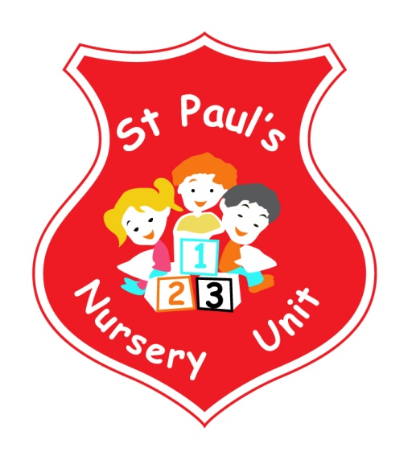
JANUARY NEWSLETTER
Themes of the Month: Winter
Colours of the Month: Blue & White

Shape of the Month: Rectangle
Number of the Month: Revision of the number 3

Hello Everyone!
Welcome back after the Christmas break! I hope you all had a very enjoyable and relaxing Christmas. The Staff would like to take this opportunity to thank you all for the lovely gifts we have received. Your thoughtfulness and kindness was greatly appreciated.
Our Christmas Show was a great success and enjoyed by all and we raised a magnificent £400 which has enabled us to buy resources for the Nursery Garden. We have also made donations to St. Vincent de Paul and the Chest, Heart and Stroke Association from money raised at the show.
Theme Of The Month
The theme in January is winter. During the month the children will have the opportunity to engage in activities which will help them to develop an understanding of the changes taking place during the winter months. We will encourage the children to reflect the Polar Regions by adding silver foil and fake snow etc. to their artwork. This will help to develop their imaginations as well as promoting an understanding of the wider world.
Homework
This month please encourage your child to identify White and Blue in the community and bring it in for our table. Mathematics – if your child spots the Number 3 or a rectangle take a photo and email it into school where it will be displayed and talked about. Email your number pictures to: stpaulsnurseryunit@yahoo.co.uk

You may have noticed we have included the children’s names along with their symbols; this is to help them recognise their own names. In addition, we will be concentrating on children’s self-help skills including taking off and hanging up their own coats. We would love to see you support us in this by encouraging your child to take off and hang up their own coat when they arrive this would help immensely as some children are unaware where their coats are located.

Fitness Freddy!

Fitness Freddie continues throughout the month of January. All children should wear Velcro trainers, every day.
Photographer

Our school photographer will be coming on Thursday 10th of January to take the children’s class photos. We look forward to seeing all the children with their best smiles on show!

Big Bedtime Read

We will be having the launch of our Big Bedtime Read initiative on Friday 18th January. Parents, guardian or grandparents are invited to come to the nursery at 1pm to join the children in listening to a story from their class teacher.

2019 Nursery / Primary One Applications

The September 2018 Application process is now available online at www.eani.org.uk. Closing date for applications is Thursday 31st January. Please contact your child’s class teacher if you have any queries or require any assistance.

Songs this Month:
- Two Little Dickie Birds
- Two Little Eyes
- Little Miss Muffet
- Hickory Dickory Dock
Reminder:
- Please pass your email address to Ms McLogan or Miss McGarry ASAP so that we may forward you your
child’s class observations.
- Your child works very hard to produce beautiful art, please remember to take all finished pieces home.
Each child has their own pigeon hole; any completed work will be placed there.
- Leave a change of clothes on your child’s peg in case of an accident.
- Please send all snack/dinner money on a Monday morning to facilitate banking.
- For Child Protection purposes - mobile phones should not be used on Nursery premises.
- Mrs McLogan is the Designated Teacher for Child Protection in the Nursery. If you have a worry or concern regarding your child, please bring any concerns to her. In her absence please see Mrs G. McCotter, Vice Principal (based in St Paul’s Primary school) contact her on 90328968.

Don’t forget to like and share our Nursery Facebook Page! Where you will find lots of information on upcoming events and pictures of the activities Our Nursery School gets up to! Search for St. Paul’s Nursery Unit and look for our school crest!

Happy Birthday to Aodhan, Caitlin, Shea and Adam who all celebrate a birthday this month!

