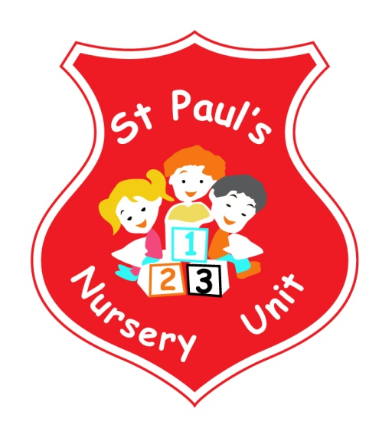

**MARCH NEWSLETTER**

**Themes of the Month:** Healthy Eating

**Colours of the Month:** **Green**



**Shape of the Month:** Oval

**Numbers of the Month:** Revise 1-4 and number 5

**Ages and Stages**

We are launching our Ages and Stages programme on Friday 29th of March at 9.00am to 10.00am for a stay and play session focused on Fine Motor Skills. Parents are invited to stay for a short information session before joining their child in their classroom.

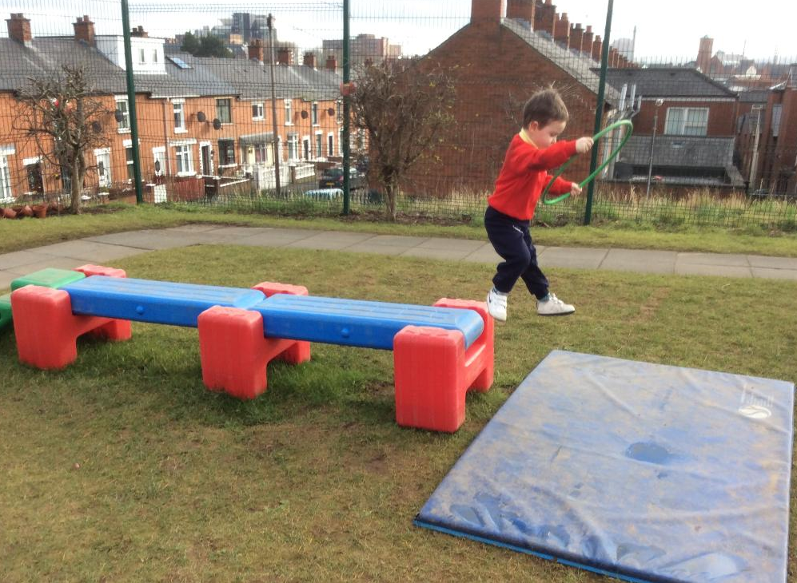

**Parent & Children Workshops**

Miss McGarry will be running an After-School workshop for our parents and children. The workshop will take place on Thursday the 21st of March from 1.30 to 2.15pm. Notes will follow with further details





**Little Tigers**

We will be starting our Little Tiger Junior Martial Arts sessions on Friday 22nd March. Please ensure children wear suitable Velcro strapped shoes.

**Green Day**





We are having our annual Green Day on Friday the 15th of March. Children can wear something green to celebrate St. Patrick’s Day. The school will be closed on Monday the 18th March 2019.



**Coffee Morning**

We would like to invite all our Parent, Grandparents and Guardians to a coffee morning on Wednesday the 3rd of April. All are welcome to come along and have a cuppa and a chat!

**Fitness Freddy**

Fitness Freddy will continue to visit our Nursery every week to keep us fit and get us moving!



Happy Mother’s Day to all our Mummy’s, Grannies and Aunties!

**Songs this Month:**

* I’m a Little Leprechaun
* Hey Diddle, diddle
* Growing Seeds
* Higgledy, Piggledy

**Dates For Your Diary**

**Friday 16th March:** Green Day

**Monday 19th March:** **School Closed**

**Thursday 21st March:** Afternoon Parent Workshop

**Friday 29th March:** Ages & Stages - Stay & Play morning

**Wednesday 3rd April:** Coffee Morning



Happy Birthday to Eamonn and Saida who both have their Birthday this month!

**Reminder:**

* Take home all of your child’s art from their pigeon hole in the hall.
* Leave a change of clothes on your child’s peg in case of an accident.
* Please send all snack/dinner money on a Monday morning to facilitate banking.
* For Child Protection purposes - mobile phones should not be used on Nursery premises.
* Mrs McLogan is the Designated Teacher for Child Protection in the Nursery. If you have a worry or concern regarding your child please bring any concerns to her. In her absence please see Mrs G. McCotter, Vice Principal (based in St Paul’s Primary school) contact her on 90328968



