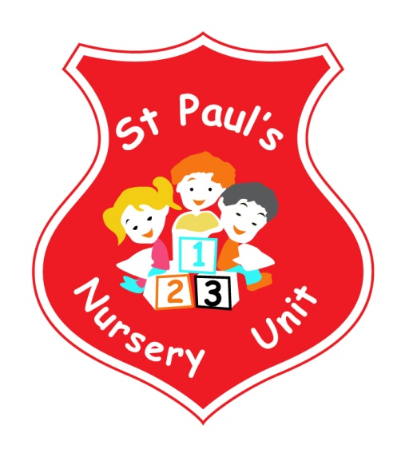
APRIL NEWSLETTER
Themes of the Month: Spring & The Farm
Colours of the Month: Yellow

Shape of the Month: Diamond
Number of the Month: 7
Theme Of The Month
The theme this month is Spring and the Farm. We will be talking about the changes in the weather, Winter to Spring and the brighter nights. The new Spring flowers and the April showers. We will also be looking at and visiting the Farm! Have a chat with your child about all the animals we might see on our visit to Arc Farm and the different types of food we eat that come from the farm.
Homework
This month we are looking at Spring YELLOW, see if you can find any yellow objects and bring them in for our table. Mathematics – if your child spots the Number 7 or a diamond, take a photo and email it into school where it will be displayed and talked about. Email your pictures to: stpaulsnurseryunit@yahoo.co.uk

Little Tigers AND Fitness Freddy!

We will continue our weekly sessions with Little Tigers and Fitness Freddy, keeping us fit and getting us moving throughout the month!

Lending Library

Our lending Library is packed full of incredible books, perfect for Bedtime Stories, please take as often as you like throughout the week.

Parent Coffee Morning

Don’t forget our Coffee Morning on Wednesday 3rd April. Come along and have a cuppa, a wee bun and a chat!

Easter Break

The Nursery will close for Easter Break at 11.00 on Thursday 18th April and reopen on Monday 29th April at 9.00. We hope you all have a lovely Easter Break!!

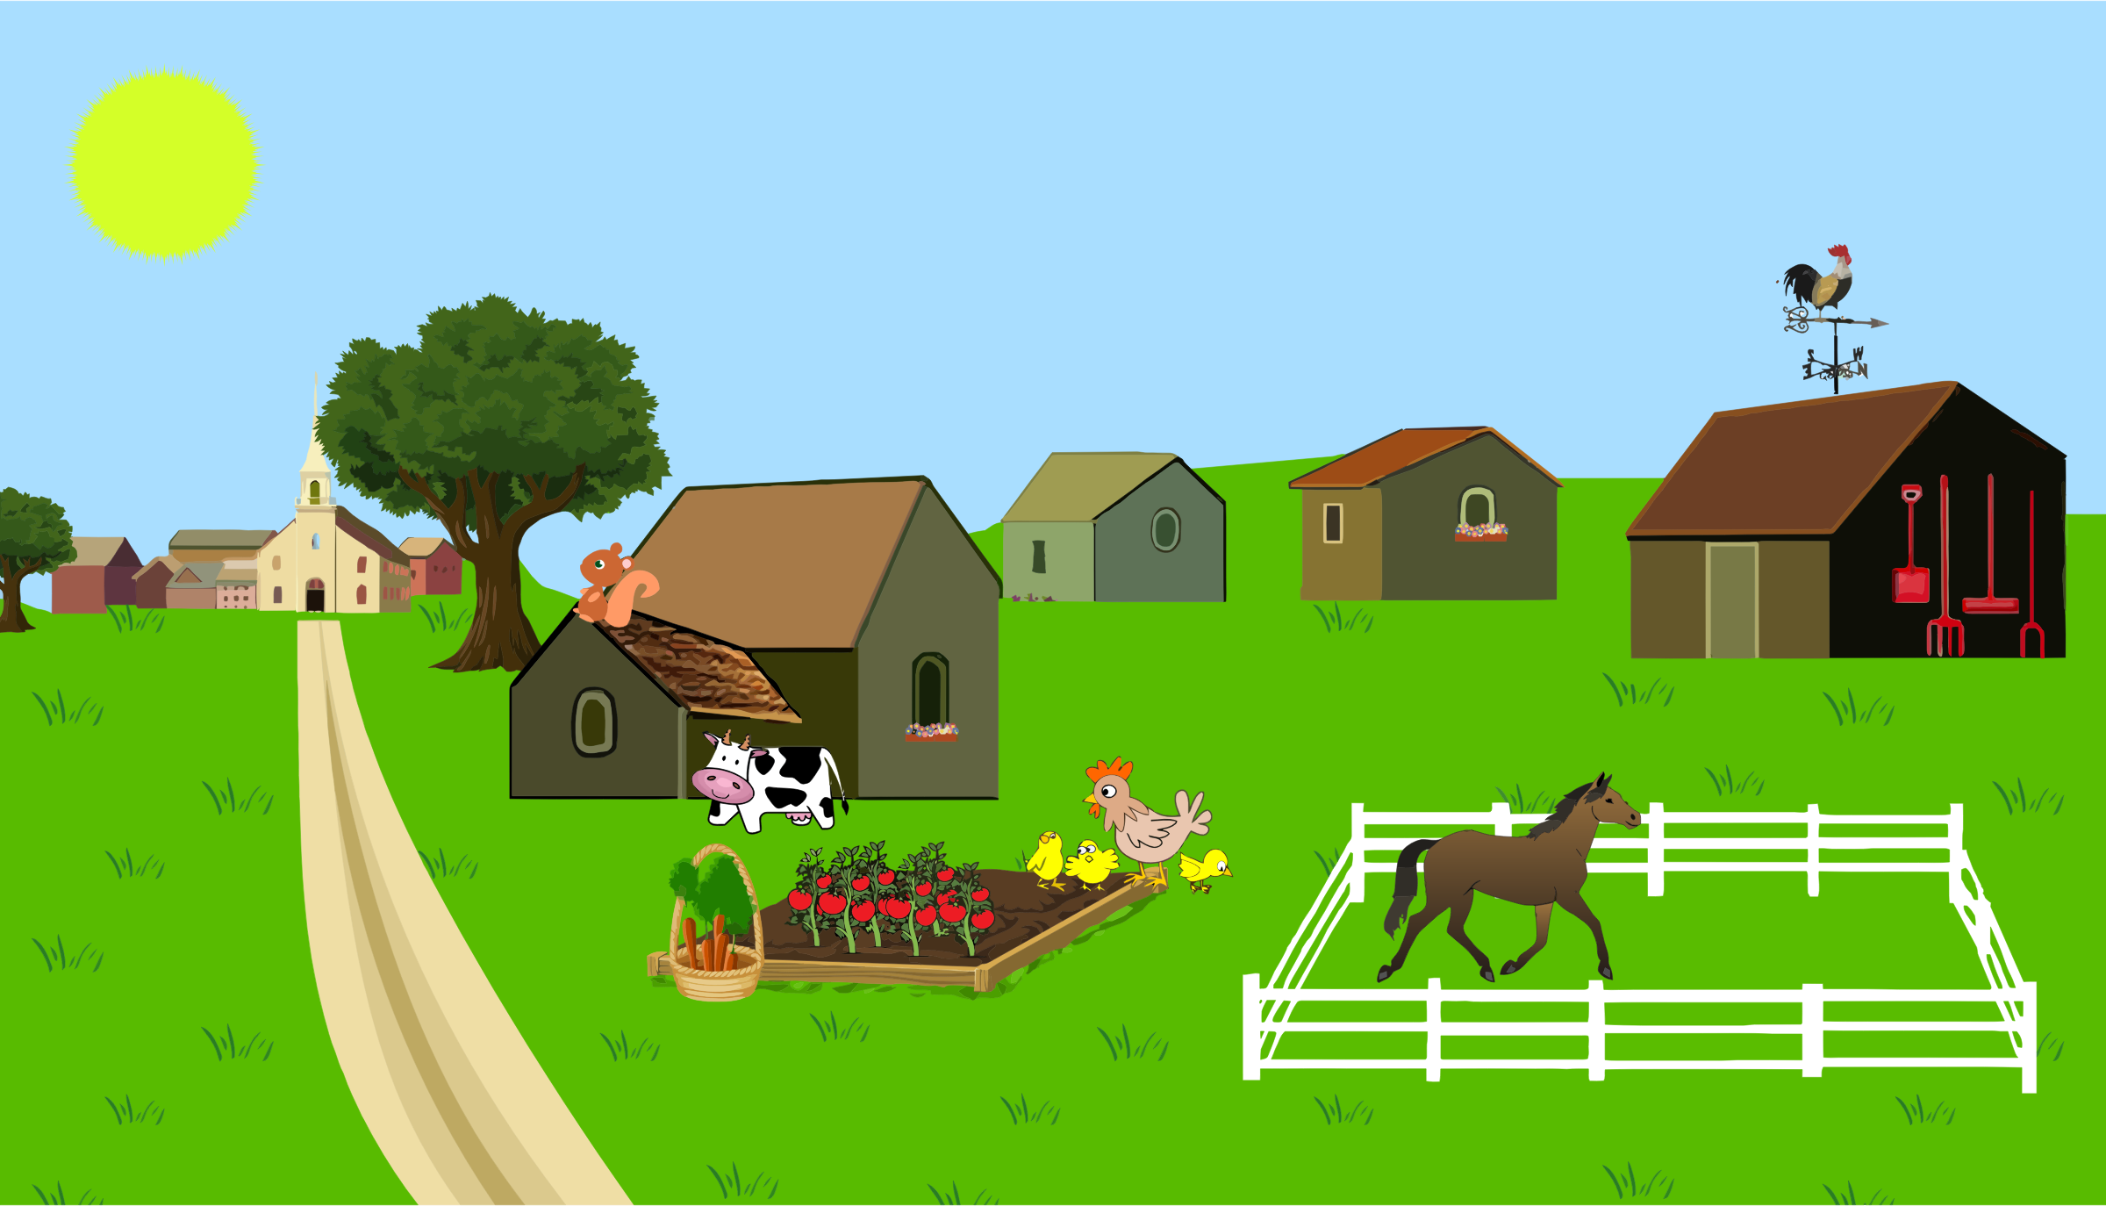

Ark Farm

Our school trip to Ark Farm will take place on Tuesday 16th April. Please ensure your child arrives at school promptly at 9.00 on this day as we will be leaving shortly thereafter. All children should come to school in their full school uniform with suitable shoes / boots and coats. The bus will drop us back to Ballymurphy Street at approximately 1.15pm. Lunch will be provided. The cost of this trip is £5.00 per child, which will go towards transport costs, this should be passed to your child’s teacher as soon as possible.

Stay and Play - Happy Healthy Kids

Thank you to all our Parents for coming along to our Stay and Play morning last month! It was a great success and we hope you all took away lots of ideas for activities to do at home with your child. We will be launching our Happy Healthy Kids initiative on Wednesday 10th April at 9.10am. We would love all to come along and stay and play again, this time focusing on outdoor activities!!

Songs this Month:
- 7 Little Ducks
- Old MacDonald had a Farm
- Little Boy Blue
- Little Bo Peep

Reminder:
- Please pass your email address to Ms McLogan or Miss McGarry ASAP so that we may forward you your
child’s class observations.
- Your child works very hard to produce beautiful art, please remember to take all finished pieces home.
Each child has their own pigeon hole; any completed work will be placed there.
- Leave a change of clothes on your child’s peg in case of an accident.
- Please send all snack/dinner money on a Monday morning to facilitate banking.
- For Child Protection purposes - mobile phones should not be used on Nursery premises.
- Mrs McLogan is the Designated Teacher for Child Protection in the Nursery. If you have a worry or concern regarding your child, please bring any concerns to her. In her absence please see Mrs G. McCotter, Vice Principal (based in St Paul’s Primary school) contact her on 90328968.

Happy Birthday to Rose, Solomon and Jake who all have their birthday’s this month!

